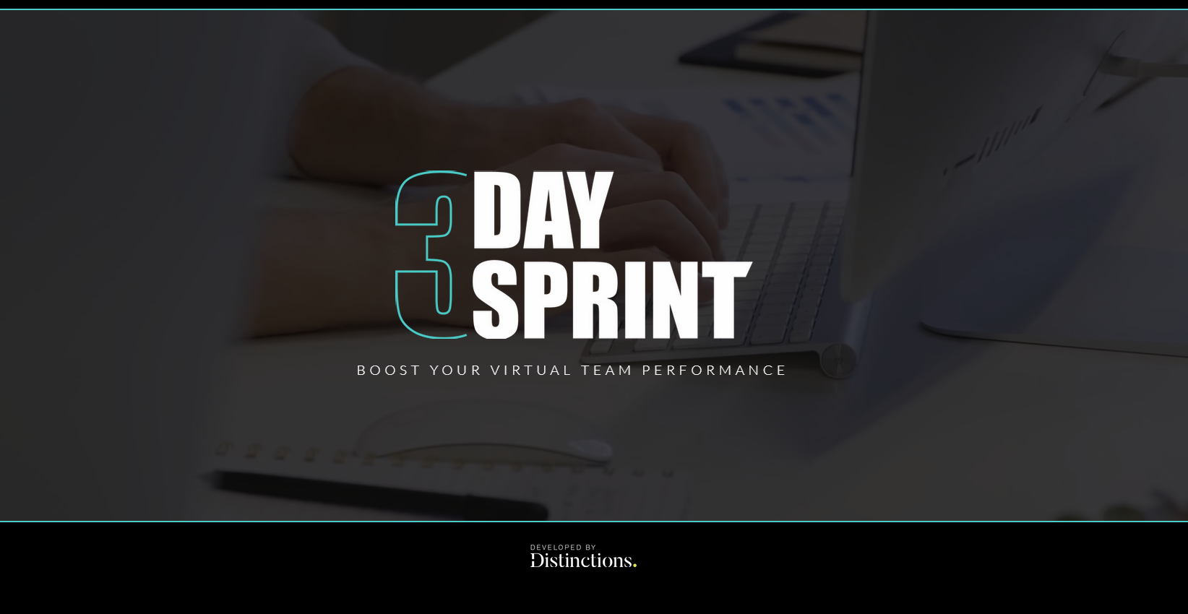 3-Day Sprint Pre-Work
Sprint One

Prepared for:
TEAM NAME/COMPANY
Facilitated by:
Your Sprint starts on …DATE & TIME.
INTRODUCTION to the Sprint
You will be taking part in high impact virtual teamwork that will enhance your virtual teaming skills and overall team performance. Your Sprint will have a practical focus, channeling learning through an agreed project. The Sprint has three distinct stages:
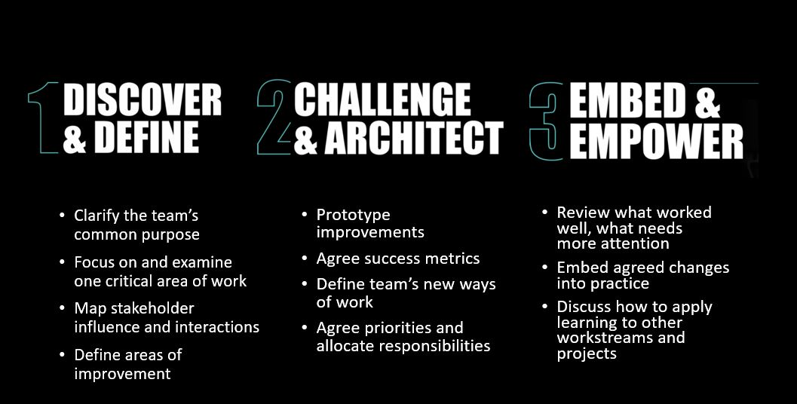
At the end of the Sprint, the team will come away with:
- a clear understanding of how as a team you maximise the positive impact of your project,
- have defined actions to move your project to the next level and
- have a better sense of how to work effectively together as a virtual team, leveraging new technology and models.

Pre-work
In order for the process to work it requires team members to come to the Sprint prepared, each having done some thinking, ready to share your thoughts and ideas on the day. Please take the time to think and reflect over the following sessions before you take part in the process.
You don’t have to return this document to us - it is for your own benefit and preparation only. It will enable you to make the most of this team development opportunity. You can choose what you share with the group one the day.
It contains four quick exercises, each requiring c. 5 mins to consider.
- Sprint Focus
- Team Identity
- Stakeholders
- S.W.O.T

The Sprint focus

Having received information on the focus of your upcoming 3-Day Sprint:
Is how it was described accurate in your opinion? Or would you describe it in a different way?

Take a few minutes to consider what the Sprint Focus means to you.
Vision: Do you have a compelling vision of the future that you believe will inspires this team to win? What are you as a team trying to create/ achieve and why does it matter?
Impact: What outcomes are important to this team? Have you agreed upon measures of success? How is can you measure this impact?
Opportunity: What does this team stand to gain or make happen? What might prevent you from achieving your vision? Consider key enablers, obstacles, and areas of opportunity.

Vision | Impact | Opportunity

The team Identity & DyNamics

Your team is not simply a functional unit, tasked with a job. It is part of your work family and how you work together affects each member of the team and those you have contact with in the wider organisation. Trust is critical to team effectiveness. Creating the foundations for trust to build is an important part of teaming. Establishing a common team identity – one that you are proud to be part of is a key step. Take a few minutes to think about what this identity looks like for this team.

If you were a fly on the wall observing the team at work:
- What do you hear this team say?
- What do people think?
- How do people feel?
- What do you see this team do?
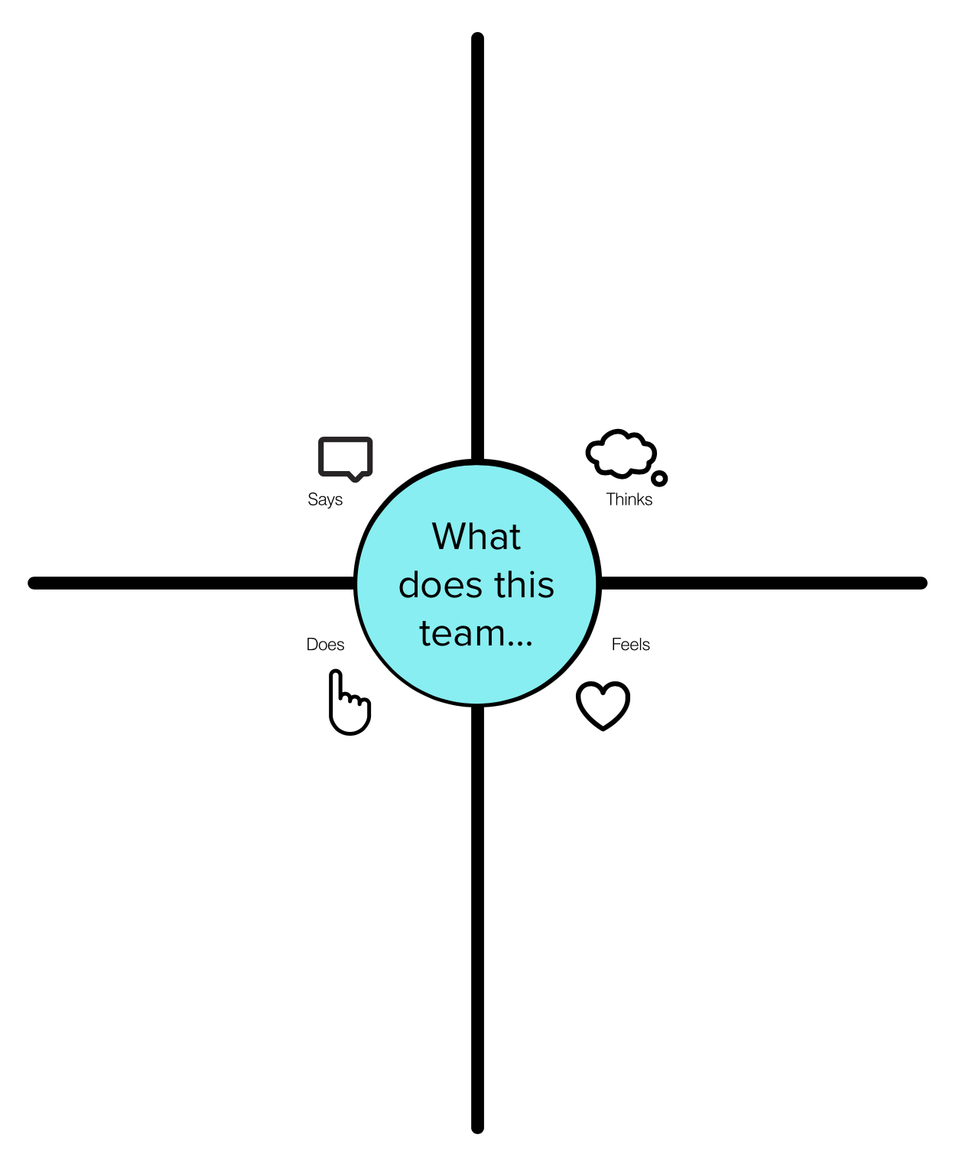

Important Stakeholders

Keep your Sprint focus in mind. Take a few minutes to identify your top 3 critical stakeholders, who have a direct impact or influence on this team’s goal –
Stakeholder Name/Group | Their Needs | Their Expectations

Team S.W.O.T.

Knowing what you know up to now about this team, its members, and the project/challenge, consider at least one Strength, one Opportunity, one Weakness and one Threat.
Strengths | Opportunities
Weaknesses | Threats

