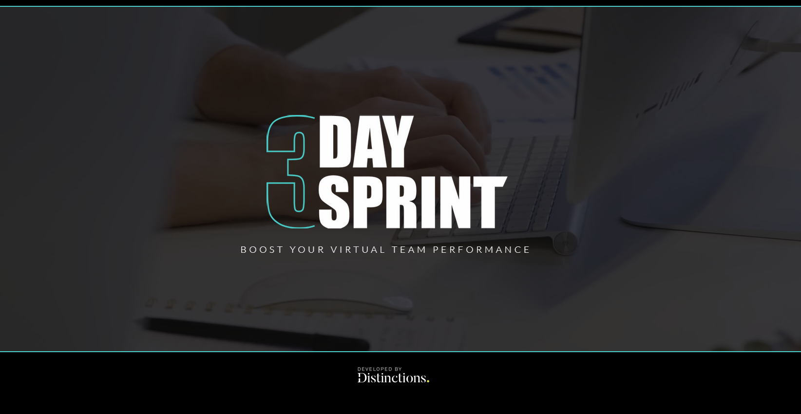 Sprint 2 - Pre-Work

Prepared for:
Facilitated by:
Date:
PRE-WORK

RETROSPECTIVE
Take time to reflect on the outcomes and actions the team agreed in Sprint One.
WHAT WENT WELL? | WHAT DIDN’T GO WELL? | WHAT DID YOU LEARN?

VISION, IMPACT, OPPORTUNITY
Revisit the contributions from day one - Sprint Focus exercise. Can you create a compelling statement for each?

VISION | IMPACT | OPPORTUNITY

ASSUMPTIONS

Reflecting on day 1, what assumptions have been uncovered or are being made so far?
Note your assumptions in the graph below, based on:
- How certain or uncertain you are about these assumptions
- Are these assumptions high or low risk to the project or challenge
High Risk
Certain
Uncertain
Low Risk

Consider: Do some of these assumptions need to be tested? How might you do that as a team?

