Sample Introduction Email
Assumption: A short informal conversation has taken place, and interest is peaked – you are seeking a meeting to discuss the 3-Day Sprint in more detail.
Dear *********,
Thank you for your time on _____ and giving me the opportunity to introduce the 3-Day Sprint for virtual teams. As agreed, below are further details that I hope will support our discussion and give you more clarity on how the 3-Day Sprint works and the benefits for … (one of your teams /the proposed team).
As mentioned, the 3-Day Sprint (3DS) virtual team training was developed by Distinctions, a management consultancy company, leveraging their on the ground experience of transitioning teams to the virtual environment through-out 2020.
The 3DS meets the challenges of remote teaming head on, using accessible technologies to deliver high impact support to teams in need of a boost in performance. It consists of a 3-hour virtual session once a week for 3 weeks, over 3 consecutive weeks.
- The Sprint has a practical focus, channelling learning through an agreed project or focused work challenge.
- During the three days, the teams will work collaboratively, leaving the sprint having progressed their project with greater confidence and understanding on performing as a virtual team.
- In addition to the immediate results, the team will build their teaming skills so they can apply their learning to other projects and work streams, creating long term ROI.

The Sprint has three distinct stages.
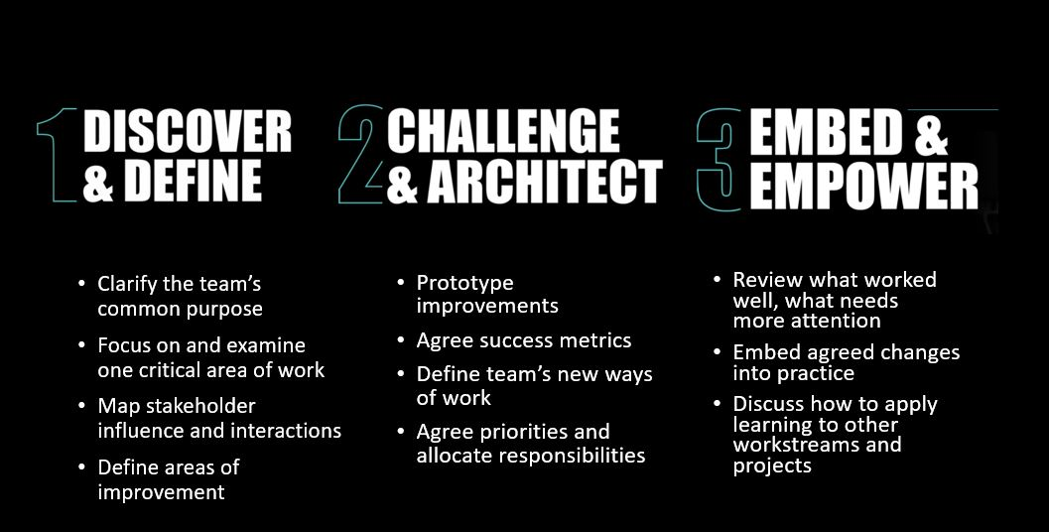
At the end of the 3-Day Sprint, the team will come away with:
- A clear understanding of how the team can maximise the positive impact of the project,
- Have defined actions to move the project to the next level and
- Have a better sense of how to work effectively together as a virtual team, leveraging new technology and models.
The ideal team:
- Will have a specific project or challenge in mind.
- Is between 4 - 8 persons in size.
- Will commit 3 hours, once a week, for 3 consecutive weeks
- Has an organisational sponsor and team leader who will give us a clear picture of the current state of the team and the project/work challenge.

Next Step:
To ensure immediate ROI, it is important that there is a clear focus for the 3-Day Sprint. To support you in this process, we will seek to carry out a team intake with the team’s key stakeholder(s). This can be done virtually and will require approx. 60 mins.
I welcome the opportunity to discuss the logistics of this with you and answer any initial questions you may have. We can include discussion on potential delivery dates and arrangements at this time, if the proposal meets your needs and expectations.
Let me know if you are interested by reply. I would be happy to discuss the Sprint and next steps in more detail with you if you would like to suggest a time for a call over the next week or two.
More information on the 3-Day Sprint is available at www.3daysprint.ie. PDF also attached.

Kind regards,

