Sprint Master Certification Pilot Team Requirement

An integral part of your Sprint Master training is securing a pilot team. It supports you to:

- turn learning into action and find your flow in delivery style and approach.
- build your confidence in promoting and delivering your new offering.
- gain a client ambassador – leveraging their testimonial and/or reference for future benefit.

As a community of practice, we will all be able to learn from your experience and apply continuous improvements of the 3DS tools, resources, and promotional materials.

Requirement:

Identifying and working with a pilot team is part of the Certification Programme Evaluation. However, it is not essential that you have a team at the time of starting the training, as we appreciate you may wish to get comfortable with the methodology before making an approach to a friendly team. It would be useful to have one or two teams in mind, as potential candidates, going into the training.

You will have 3 months to complete a Sprint with your Pilot team, post training. We will be there to support you each step of the way, in any way we can. For evaluation, you are asked to write up a case study, featuring key learnings. This is not prescriptive.

A few recommendations:

To ensure you create a good practice environment for yourself, it is important that the pilot team understand that this is part of your certification. On this basis, we would not expect you to charge the team for this engagement. Thus, a license fee will not apply, where you have offered the Sprint on a pro-bono basis.

Other contracting terms you may wish to establish with your pilot team:
- team must have a specific project or challenge in mind.
- team is between 4 - 8 in size.
- the team will need to be available for 3 hours, once a week, for 3 consecutive weeks starting week of …DATE.
- The team's key stakeholder will need to be available for a 1 hr virtual consultation before the teamwork begins, and again 1-month post teamwork.
- Advocacy support:
  - The stakeholders agree to act as a referee, sharing their honest experience of the work carried out.
  - The team and key stakeholder will be asked for feedback and a testimonial which may be used for promotional purposes.
  - A case study may form part of promotional content. This case study will contain high-level information only and approval will be sought before use.
Communicating with a potential pilot team

We recommend you leverage the sales and promotional aids provided to you in the Sprint Master Guide, giving yourself the scope to adapt the language to suit your style. In addition to this, below is sample wording you can use when seeking your pilot team.

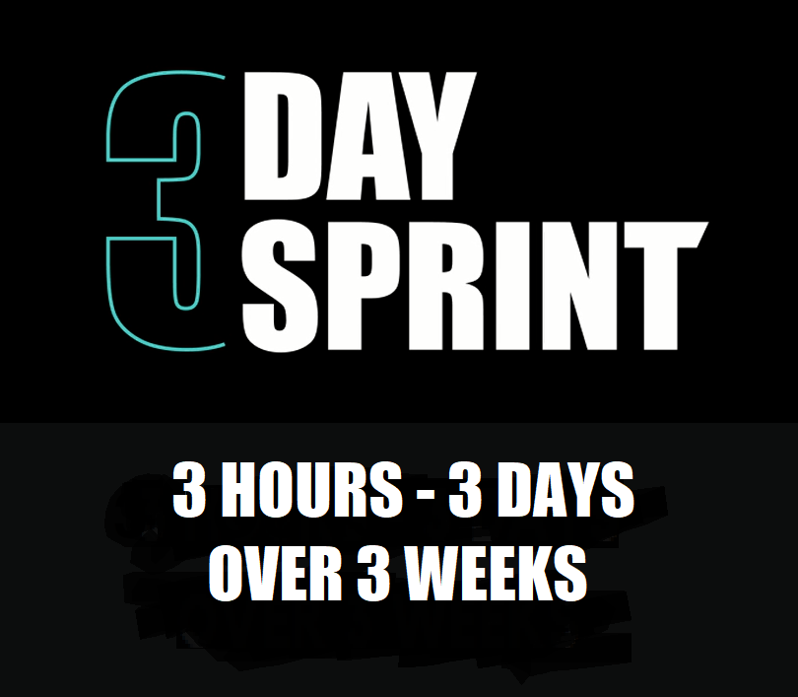PRO-BONO TEAM DEVELOPMENT SUPPORT VALUED AT €2.5K

Dear,

Our new offering to support virtual teams is ready - we are looking for a pilot team to work with to gain insights and feedback.

This is a pro-bono team development offer valued at €2.5K. The 3-Day Sprint (3DS) meets an immediate need in the market, delivering high impact support to teams in need of a boost in performance. It consists of a 3-hour virtual session, once a week, over 3 consecutive weeks.

Teams pick one area of focus and learn how to architect more effective ways of working together. During the three days, the teams will work collaboratively, leaving the sprint having progressed their project with greater confidence and understanding on performing as a virtual team. In addition to the immediate results, the team will build their teaming skills so they can apply their learning to other projects and work streams.
The 3-Day Sprint was developed by Distinctions, a management consultancy company, leveraging their on the ground experience of transitioning teams to the virtual environment through-out 2020. I am currently training to be a Sprint Master Facilitator and as part of this certification training, I am required to work with a pilot team so that I can turn learning into action and also gain insights and feedback. I/we thought about your organisation, be it your own team or a project team that may need support on a project or challenge.
Criteria for participation:
- team must have a specific project or challenge in mind.
- team is between 4 - 8 persons in size.
- the team will need to be available for 3 hours, once a week, for 3 consecutive weeks between now and ….
- The team's key stakeholder will need to be available for a 1 hr virtual consultation before the teamwork begins, and again 1-month post teamwork.
- In return, we would welcome your advocacy support which may include acting as a referee, a testimonial and/ case study write-up which may be used for promotional purposes.
Let me know if you are interested by reply. I would be happy to discuss the Sprint and next steps in more detail with you if you’d like to suggest a time for a call over the next week or two. More information on the 3-Day Sprint is available at www.3daysprint.distinctions.ie

